Date of Match 30 Mar 2021  KO Time 10:30 am  Away Team Accrington Stanley Youth  Home Team Ashridge Park Royals  Home Colours Blue & White Stripes  Pitch Pitch C  League Section G Match | Coach Contact Bill McLeod Jacobsen 07855 378 008  Referee Stéphanie Frappartfaroe £12 per team  Address St Crispin’s School, London Road, Wokingham, RG40 1SS  Address Cantley Park, Twyford Road, Wokingham, RG40 5QG  **Delete the appropriate address above in regards to your match**

St Crispin’s Venue Information

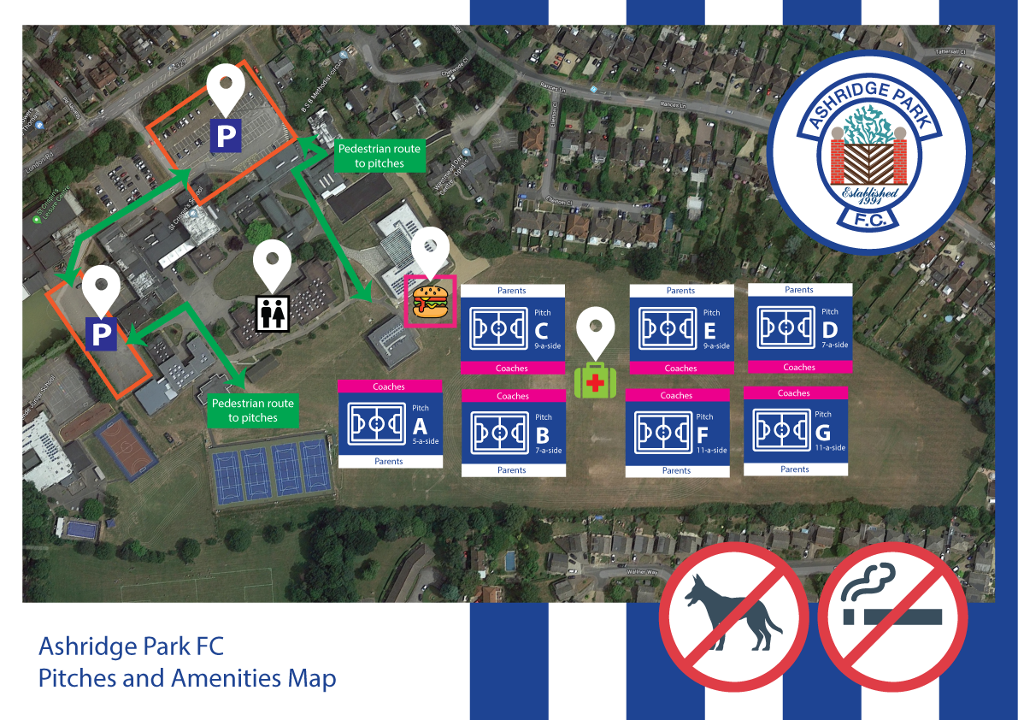

Respect Guidelines  Ashridge Park implements spectator barriers beside all of the pitches in accordance with the RESPECT Programme.  We respectfully ask that all spectators enjoy the match from behind those lines, observe the code of conduct by being positive & encouraging to all the players in the game and to respect the referee’s decisions.  Catering  Refreshments are available in front of the Science Block which you pass on your way to the pitch. | Head Injuries  We require all teams to adhere to FA guidelines on head injuries.  Photography  We allow photography of our games at Ashridge Park; if you do NOT wish photographs to be taken at the game then please inform the Ashridge Park coaches beforehand.  Dogs  Please note, we ask that you leave dogs at home, as they are NOT allowed at St Crispin’s.

Ashridge Park First Aid – Emergency Action Plan

- Each team has a qualified First Aider. All Managers and Coaches must ensure they have an up to date certificate or recognised qualification, i.e. less than 3 years old. Ensure that you are aware of all your player’s pre-existing medical conditions.
- Each team has an up to date First Aid kit that is kept fully stocked. The kit must be available at training and games
- There must always be at least two adults present with a mobile phone at training sessions and games.
- The pitch should always be inspected before training or a game commences for any sharp objects/broken glass or anything else that could cause injury.
- Be familiar with your surroundings. Know the full address where you are playing including the post code. These are the details for our home games:
St Crispin’s School Cantley Park
London Road Twyford Road
Wokingham Wokingham
RG40 1SS RG40 5QG
- Ensure access to the pitch is available for an Ambulance, i.e. respect boards/barriers/cones are in place and the gate is not padlocked. If you need to call an Ambulance, please dial 999.
- Know where the nearest hospital to the ground you are playing at is.
Royal Berkshire Hospital
21 Craven Road, Reading, RG1 5LE
0118 322 5111
- If you have to treat a player for an injury that requires hospital treatment, then keep a note of the details, time, and what happened for future reference. Please forward the details to the Club Secretary.
- Limit your First Aid treatment and/or advice to the knowledge and practice in which you are formally trained. Carry and use only medical items that you have been trained to use.
- Protect yourself, others and the casualty. Do what is necessary to prevent deterioration of the player’s condition while awaiting the arrival of Emergency Services.

Venue and Directions

St Crispin’s School, London Road, Wokingham RG40 1SS ( https://goo.gl/maps/ieu4a6jf6bw )

From M3, Junction 3  - Take A322 North to Bracknell  - At Bracknell follow A329M to Wokingham  - Take Wokingham exit, and stay in left hand lane  - Take 1st exit from roundabout, and head to Wokingham  - Take the middle lane at first lights  - Keep going straight at second lights  - St Crispin’s School entrance is on the left  From Finchampstead  - Head for Wokingham on A321  - Keep on A321 past Tesco and BP garage on your right  - At roundabout take 2nd exit to Train Station  - Stay on this road, at traffic lights keep going straight, past Train station  - At the top of the road be in right hand lane and turn right to Wokingham  - At traffic lights bear left (be in left hand lane past Waitrose then use right hand lane after Waitrose).  - Straight through traffic lights and bear right at the bottom and then take the left-hand lane.  - Bear left at the top (Next to Church and The Ship pub)  - St Crispin’s School entrance is on the right just past the traffic lights & Shell Garage. | From M4 Junction 10  - Take A329M South to Wokingham  - Take Wokingham exit, and stay in left hand lane  - Take 1st exit from roundabout, and head to Wokingham  - Take the middle lane at first lights  - Keep going straight at second lights  - St Crispin’s School entrance is on the left  From Winnersh/Woodley/Earley  - Follow the A329 (Reading Road) to Wokingham  - As you come into town take the left hand lane past Council Offices  - At traffic lights bear left (be in left hand lane past Waitrose then use right hand lane after Waitrose).  - Straight through traffic lights and bear right at the bottom and then take the left-hand lane.  - Bear left at the top (Next to Church and The Ship pub)  - St Crispin’s School entrance is on the right just past the traffic lights & Shell Garage.

Cantley Park, Twyford Road, Wokingham RG40 5QG (https://goo.gl/maps/ynUQEnr8JEsf8BeJ8 )

From Wokingham Town Centre  - Take the Reading Road A329 out of town heading to Winnersh/Reading  - Continue straight at the traffic lights passing Station Approach on your left  - As you pass St Pauls Church on your left take the first road on your right Holt Lane  - Continue down Holt Lane past Holt School to the end and turn right onto Jubilee Avenue and then turn immediately left onto Milton Road  - At the roundabout turn right onto Twyford Road  - Cantley Park is the first junction on your right | From Winnersh/Woodley/Earley  - Follow the A329 (Reading Road) to Wokingham  - Continue straight on the A329 at the Woosehill roundabout  - Take the third left junction onto Holt Lane  - Continue down Holt Lane past Holt School to the end and turn right onto Jubilee Avenue and then turn immediately left onto Milton Road  - At the roundabout turn right onto Twyford Road  - Cantley Park is the first junction on your right
3G Pitch Footwear Guide
Please note if you are playing on our 3G pitch at Cantley you must wear Moulded Circular Multi-stud Boots
All footwear must be clean before entering the pitch area.
The Following footwear is not approved for use on 3G
- Astro or 3G Training Shoes – Astro boots (dimpled) or 4G training shoes (flat soles)
- Boots with Plastic Blades
- Boots with Metal Studs or Metal Blades
- Flat Soled Shoes

MATCHDAY RULES
COACHES
DON’T…..
- Attend matches if you feel unwell, even if your symptoms are not related to
COVID-19
- Attend matches if you live with a person who is shielding or self-isolating
- Handle the ball unnecessarily
- Arrive more than 30 mins before the match
- Spit, cough or shout unnecessarily

DO…..
- Try to accept the KO time you have been allocated and restrict requests for specific times
- Advise opposition managers of a safe location to warm-up
- Maintain appropriate PPE, in the form of masks and gloves in First Aid kits
- Request parent/guardian assist should first aid be required
- Inform another coach or club official if you feel unwell during a match
- Leave the site as quickly as possible at the end of the match
- ENJOY PLAYING FOOTBALL AGAIN!!!
MATCHDAY RULES
PLAYERS
DON’T…..
- Attend matches if you feel unwell, even if your symptoms are not related to
COVID-19
- Attend matches if you live with a person who is shielding or self-isolating
- Take too long on corners and free-kicks, in order to minimise periods of close proximity
- Arrive more than 30 mins before the match
- Spit, cough or shout unnecessarily
DO…..
- Inform a coach if you feel unwell during a match
- Leave the site as quickly as possible at the end of the match
- ENJOY PLAYING FOOTBALL AGAIN!!!

MATCHDAY RULES
REFEREES
DON’T…..
- Attend matches if you feel unwell, even if your symptoms are not related to
COVID-19
- Attend matches if you live with a person who is shielding or self-isolating
- more than 30 mins before the match
- Spit, cough or shout unnecessarily
DO…..
- Inform the home manager if you feel unwell during a match
- Leave the site as quickly as possible at the end of the match
- ENJOY PLAYING FOOTBALL AGAIN!!!
MATCHDAY RULES
SPECTATORS
DON’T…..
- Attend matches if you feel unwell, even if your symptoms are not related to
COVID-19
- Attend matches if you live with a person who is shielding or self-isolating
- Arrive more than 30 mins before the match
- Spit, cough or shout unnecessarily
DO…..
- Allow the referee’s assistant sufficient space to safely travel the length of the touchline
- Assist with First Aid as required for your child
- Inform a coach or club official if you feel unwell during a match
- Leave the site as quickly as possible at the end of the match
- ENJOY WATCHING FOOTBALL AGAIN!!!

